Matthew “Jack” Koch
Professor C.Miller
Govt 490
23OCT2019
Some American Dream
For the paper assigned on art I dragged myself into the District, down to the National Portrait Gallery, and took Eric along for the ride. I was interested in finding an “Americana” piece that spoke to me about the importance of wealth and not necessarily money. I am captivated by the third floor of the portrait gallery because of the focus on the Americas. Influential Americans have historically been, but not always, rich and powerful. As synonymous as power is to wealth, it is also akin to status in the classic American food chain.
Two of the greatest and most influential people to have participated in the American experiment are Melinda and Bill Gates. The Gates family have been depicted as a sort of anti-hero by many in the wake of the cataclysmic shit show that has been capitalism in the first part of the 21st century. Bill has tried to emulate the industrialists Rockefeller and Carnegie by becoming a large scale philanthropist. By starting the Bill and Melinda Gates Foundation, Gates has started the world’s largest non-profit organization, with a value of almost 40 billion dollars. With a large, nation-sized budget, the organization has the purview to start and fund scholarships and development projects across the United States. Its main focus is to improve the sciences in North America by providing the structures and tools necessary to teach upcoming youth. It is all of these ideas that have created what I call “New American Carnegienism”. Are the people that profit off of shady business techniques and manufacturing loopholes able to absolve themselves by mere charity? Surely, Bill and Melinda have never taken part in these practices, but just as the President is held accountable for strategic mistakes, the big boss must be held accountable for the shortfalls in ethical business behavior.
The portrait below is included in the same room along with First Lady Michelle Obama and all of the prominent generals of WW2 and the Civil War. It is in the company of some of the most influential members of the American public since the beginning of the republic, and as such connotes a sense of immediate importance. The portrait itself is important for context to the overall scene. When looking closely, it is crucial to see the body language of both of the Gates’s as they sit. Melinda is in a dominant position, sitting firmly in the chair, which has been historically occupied by the more powerful of the duo. In the power dynamics of a successful relationship, it is likely to assume that Bill and Melinda have subscribed a method of compromise that has allowed them to last for a lengthier stint than some. The background is located at the Gates residence outside of Seattle, which has been speculated by some as costing upwards of 127 million dollars. The most ironic part of the photo is that there is no mention of Microsoft, technology, or even wealth. Neither of the couple feature gaudy jewelry or kitschy clothing. Although they have a combined net worth that approaches 130 billion dollars the Gates’ lasting legacy is their philanthropic work. They may be the most discreet and reserved power couple.
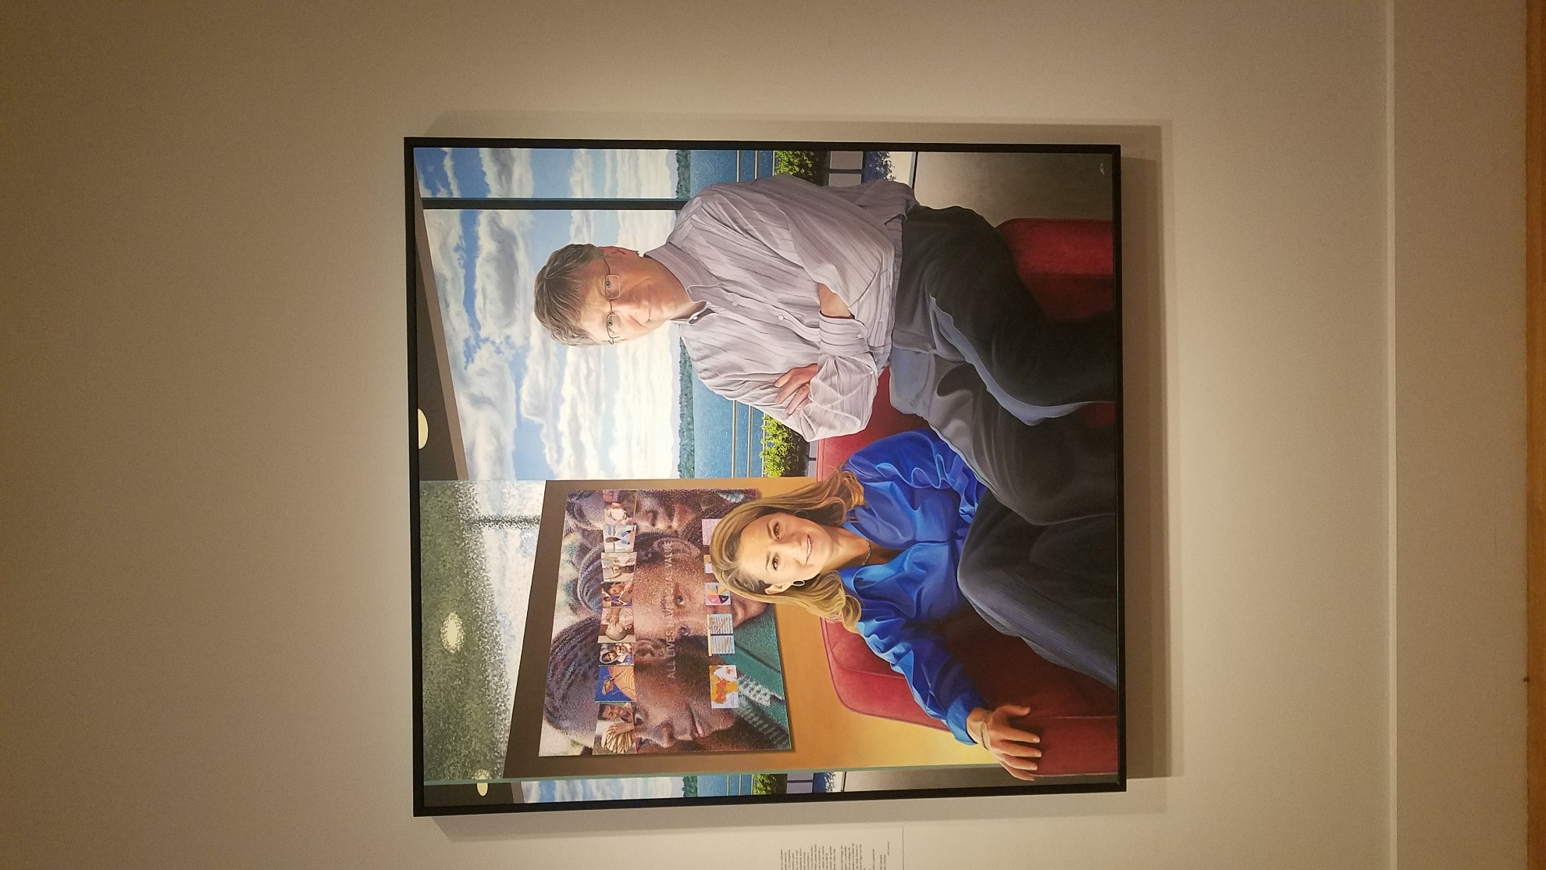
The contrasting portrait is actually a full exhibit that has been semi-permanent since its inception in 2001. Sollie 17 gives us a glimpse into how old age and the feeling of uselessness contribute to the gloomy reality that is “going over the hill”. Despair and the loneliness of ageing are compounded when you realize that the American society largely discards the elderly and very rarely do families live in multi-generational homes. In a society that values money and the significance that one can bring to a business it is not unreasonable to expect that once a person reaches retirement age they are discarded in favor of someone younger and more able to produce. In a roundabout way this can be linked to the exploitation of people as merely labor and not individuals. I have never subscribed to the philosophy of Marx but it is interesting the amount of reverence that older generations are treated with in countries like Malaysia, Japan, and Mexico in contrast to the United States. Thinking globally for a bit it seems that the need for innovation and the clash of the new wave of nationalism puts many people at a crossroads for values. How will those who cannot adapt to a changing technological world be treated? In a way money has allowed many older people to circumvent the necessary changes by outsourcing skilled labor to the likes of Best Buy and the local tech shop. But how long is it until the invention of “smart technology” relegates old timers to antiquity. Maya Angelou once said “Most people don't grow up. Most people age. They find parking spaces, honor their credit cards, get married, have children, and call that maturity. What that is, is aging.” The National Portrait Gallery is a place to view many things that have to do with money, whether they are on the nose like the portrait of the Gates or more abstract like Sollie 17. What drives the talented and creative painters who are appointed to paint these masterpieces? American culture is surrounded by the desire to gain notoriety whether it be through power or prestige. Americans more than anything have one common fear that binds us in a society, we crave wealth. Spiritual wealth, monetary wealth and the wealth that comes with being recognized. As Americans age, we tend to value less in material good and more in spiritual well-being. Older Americans polled higher when asked about spiritual connection as well as the values that are compatible with spiritual well-being. So what does this have to do with money or currency? There is some undoubtable connection between ageing and the need for less money. Of course this is usually because a lifetime of accumulation of wealth has set older people up for retirement. But I believe as people hit their last golden years it is a fear of death, and the inevitability of not buying more life that compels people to seek spiritual well-being.
