Matthew “Jack” Koch
Prof C.Miller
GOVT 490
02OCT2019
The Bubble and the Crash
Buying a house is a great way to invest. If you have smart parents then more than likely you have heard this phrase more than a few times. But on the surface the idea of buying property is more appealing than the practice of investing. For many years the lending practices of banks were very shady. To appeal to the lower classes that were trying to purchase a home these banks offered adjustable rate mortgages. The adjustable rate mortgage works much like a cable deal with bad terms, to start a “lure” is set at an incredible interest rate of <5% for those who don’t have great credit. Then after ten years the rate can be adjusted to whatever the bank would like to charge. This, in some instances, can mean that the bank can charge as much as 35% percent interest on a 30 year loan.
These were crippling for persons who had not agreed to these terms and had taken a mortgage based on a low rate. In 2019, after the decline of many of the predatory lending institutions and the bailout period under President Obama these rates have been adjusted. The negative amortization phenomenon occurred when a monthly loan payment was too small to cover even the interest, which was then added to the unpaid balance. It can result in a borrower owing substantially more than the original amount borrowed. The rates have been lowered to be based around what the Federal Reserve sets interest rates, present hovering around 5%. This was coupled with the government creation of what was called the bailout, otherwise known as the TARP fund or Troubled Asset Relief Fund. TARP was an ambitious program that was created in 2008 and signed into law by President G.W Bush. It was created to try and buy some of the financial assets to manage and offload them as a way to not fully crash the market. In theory this was created so that the Treasury could purchase the largest shares of assets off of the nine largest US lending institutions. This was done in an effort to make these banks solvent again and to try and resume practices prior to the crash.
The main players in the portion of the crash that was highly publicized included Fannie Mae and Freddie Mac as well as Bear Stearns and JP Morgan Chase. All of these investment banks were heavily cast in the volatilization of the market. They contributed to the downfall by participating in a practice known as Collateral Debt Obligations and Credit Default Swaps. Collateral Debt Obligations or CDO were a tricky way for these investment giants to fool the uninformed investor. These CDO were packaged financial asset platforms that packaged bonds and mortgages in categories such as AAA, AA,B and so on. These “grades” for the metric of financial richness or stability were inherent to the crash. In simple terms these banks were packaging CDO in a way where they were sold as AAA and marketed as infallible but under the surface they were laden with B rated credit assets. These mortgages were packaged discreetly so as to not alarm traders and to take advantage of a small loophole in trading. This loophole was exploited by holding these unpackaged mortgage CDO on the books for as small of time as possible and essentially playing “hot potato” by offloading these CDO before the credit is evaluated by the firm’s compliance department. In was in this manner that the CCO of most of these companies were found to not be of any wrongdoing in many 2008 congressional findings. By hiding the true value and misrepresenting the default probability these could be sold at a level of A or AA.
With these general practices becoming rampant in the latter stages of 2007 the “bubble” was formed. This bubble was realized by several key figures who include Michael Burry of Scion Capital and John Paulson, these traders understood that by creating Credit Default Swaps they could buy insurance and short this crash that was due in the latter part of the first decade of the 21st century. These events have been popularized in Aaron Sorkin’s Too Big to Fail and the Movie Margin Call as well as many books and memoirs. The more interesting aspects of the financial crash to me include the events that built these CDO and the idea of a “bailout”. The bailout period was a time where the idea of capitalism has been criticized by Americans in large and has led many to second guess capitalism as a dominant motivation for social classes and structure of the American ideal. Starting under the Reagan administration the idolization of fast money on Wall Street and the phenomenon of making a quick million were at the height of popularity. Men like Jordan Belfort and the events that were dramatized in “Wall Street” with fictitious characters like Gordon Gecko led to a fun but pervasive and important question….is it moral to make a shitload of money?
As a consequence of the events of the financial crisis and crash of 2008 the American people are at the height of distrust of the financial sector as demonstrated here. Americans who had put all of their entire lives into providing for their family and putting a house over their heads were devastated. “U.S. foreclosure filings spiked by more than 81% in 2008, a record, according to a report released Thursday, and they're up 225% compared with 2006.A total of 861,664 families lost their homes to foreclosure last year, according to RealtyTrac, which released its year-end report Thursday. There were more than 3.1 million foreclosure filings issued during 2008, which means that one of every 54 households received a notice last year.” ( CNN,2009) The events of the crash have yet to fully play out and in true American fashion most have a short memory about the potential consequences of lending by banks without true oversight. In the graph below the statistics are laid out based on the US Census Bureau.
APA: St. Louis Fed. (February 28, 2019). Homeownership rate in the United States from 1990 to 2018 [Graph]. In Statista. Retrieved October 01, 2019, from https://www.statista.com/statistics/184902/homeownership-rate-in-the-us-since-2003/
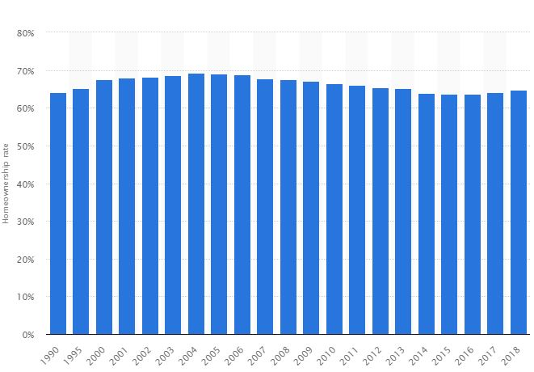
Although Americans declined in home ownership since the build of the bubble from 2000 to 2006, consumer confidence seems to be returning. The last question I would pose is can Americans trust lending institutions even amidst the bailout rebuild process?

